We Are in The Final Hours; What You Can Do
October 7, 2017

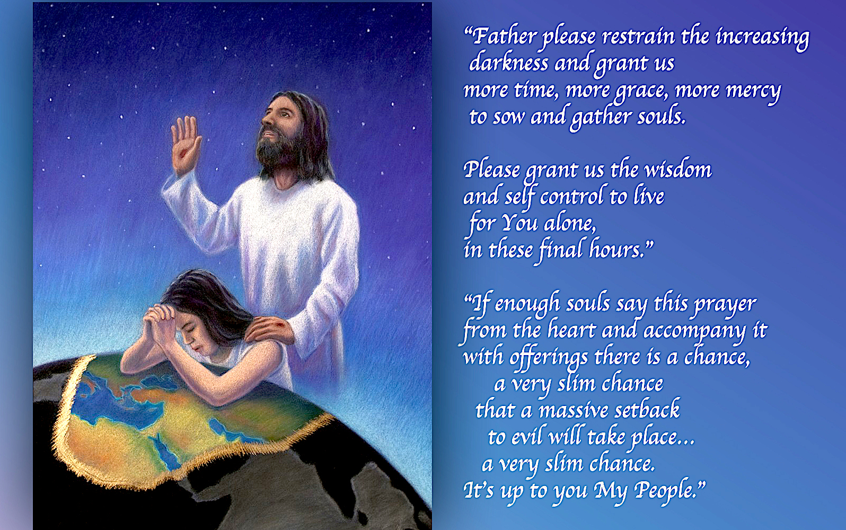
Jesus, please help us to live for You alone in these final hours before Your coming. Amen

Well, my dear Heartdwellers, the Lord is sending out the clarion call! We are at the end of the time of probation that was supposed to last for three years. Unless something changes, we have no more time left.

Ezekiel and I were counting up the signs the Lord is giving us in the Communion Service readings, in the Rhema book, in the Scriptures—and they are alarmingly targeting the Lord’s coming. Over and over again.

Not to mention the dreams that we've been having.

And this is typical of the readings we've been getting for our communion services:

"When you hear of wars and uprisings, do not be frightened. These things must happen first, but the end will not come right away.”

“Nation will rise against nation, and kingdom against kingdom. There will be great earthquakes, famines and pestilences in various places, and fearful events and great signs from heaven.

“But before all this, they will seize you and persecute you. They will hand you over to synagogues and put you in prison, and you will be brought before kings and governors, and all on account of my name. And so you will bear testimony to me.

You will be betrayed even by parents, brothers and sisters, relatives and friends, and they will put some of you to death. Everyone will hate you because of me. But not a hair of your head will perish. Stand firm, and you will win eternal life.

“There will be signs in the sun, moon and stars. On the earth, nations will be in anguish and perplexity at the roaring and tossing of the sea. People will faint from terror, apprehensive of what is coming on the world, for the heavenly bodies will be shaken. At that time they will see the Son of Man coming in a cloud with power and great glory. When these things begin to take place, stand up and lift up your heads, because your redemption is drawing near.” Luke 21:9-13, 16-19, 25-28

I began to speak to the Lord at that point, and I said, "Oh Lord, I am so stirred by the urgency before me. Please tell me, please tell me—is it that close? Let not a spirit of deception seep in and speak. Let the words I hear be You, Jesus, for my heart is troubled."

At that point I started crying, and He said my name:

"Clare, Clare" …my head was down, but He lifted my chin. “I am not abandoning you, do not be afraid. Ample provision is made for you and your children. I know your concern.

"Yes. the time is at hand, it truly is.”

But what about our prayers and the three years?

"Did I not say it was provisional?"

But I thought we were applying ourselves?

"Not as much as is needed. Yet, there is still hope…a flicker…nothing more. I will not give you over to deception. There is a remote possibility that you will make it to three years. But this requires much more sacrifice than My people are willing to make.

"Besides, I see how tired My Bride is getting."

Wow, He's got that right...

"I know the desire of your heart, the oppression you fight against, not the least of which is your own frail flesh. I see it all and I am telling you—time is running out. You must stir Heartdwellers up, once again, with the clarion call. Time is running out; evil is escalating… What are you willing to do for Me, My Bride, to stop this acceleration of evil?

"You see, it is the world again. The world demands so much time and energy from My people, at the end of the day it is as you perceive it—no more strength is left to fight the tide of evil. Concerns of the world have drained you.

"Yet you must interface with the world to get where you are going. Clare, it is very difficult to shut out the world when you still must deal with it. I see your efforts and where you have failed and as I made you aware earlier in the evening, this time now is very strong with oppression."

Yeah, I just want to make a note of that. Before the Satanic feast days, oppression is heavy. Before Halloween.

He continued, "It is very difficult for Me right now, weighing the options—seeing the good bringing forth fruit; seeing the bad destroy it. The battle is fierce, as you discovered when you saw your angels in a recovery ward. Nevertheless, there are more with you than against you. As long as you stay in My will and obey what you know to be right, not giving in to any worldly impulse.

"My dear, dear Heartdwellers, we are on the final leg of the journey. How I wish it could be postponed—and perhaps yet a miracle could happen. But as things stand, they are rapidly deteriorating and need your constant prayer. The world is still attractive to some of you and that hampers your time and focus on prayer and on Me. As you let these things of the world go, I fill you again with My Spirit, to enable you to intercede.

"Do not be overly discouraged. Some of you have fought hard. Keep fighting. Keep hoping. Keep offering and perhaps the grace to avoid events will be given. But it is going to take more effort.

"Please spread the word, even organize small prayer cells with others to pray and fast specifically for the world and this nation and that anti-Christ will not get his way until I am ready to turn him loose.

"This prayer is VERY important: (here is the prayer) 'Father, please restrain the increasing darkness and grant us more time, more grace, more mercy to sow and gather souls. Please grant us the wisdom and self-control to live for You alone, in these final hours.'

“If enough souls say this prayer from the heart and accompany it with offerings, there is a chance—a very slim chance—that a massive setback to evil will take place. A very slim chance.

"It’s up to you, My People.

"Pray this with all your hearts and give to Me every offering, going about and doing good at every opportunity. Leave no good work undone. Offer to Me every struggle, pain, delay, and sickness that I do not cure with prayer. And everything else you suffer."

At this point, the Lord stopped talking and the Scripture came to mind:

'Now I rejoice in my sufferings for you, and I fill up in my flesh what is lacking in regard to Christ’s afflictions for the sake of His body, which is the church.' Colossians 1:24

So, obviously Paul had some physical infirmity that was an offering to the Lord. Not only to keep him humble, but for the conversion of souls.

So, my dear Heartdwellers, I am asking all of you to lend a hand, to get this prayer out all over the Internet. I don’t know how to do ads on the Net but I’m asking for help. If any of you are experienced in this, please help me. I have some artwork and words; they should be completed tomorrow. And we have a budget to spread this hopefully world-wide.

If you can help, please leave contact information in a private message to us and we will be in touch. Let's gather together family and shout this prayer from the roof tops!!

God bless you, Beloved of His Heart.

